DOM: DOM means Document Object Model and we all know that but what is that exactly??!!

Document: Whenever we load a page it is a document cause there are lots of HTML inside that page and that is the Document. Whenever we will see the backside of a webpage, you will see lots of documents HTML codes.

Object: Inside that HTML code JavaScript counts every tag as an object and JavaScript can manipulate those objects.  
<head>,<ul>,<p>,<li>,<a>,<body>,<h1> etc.  
everything is considered as object by the JavaScript

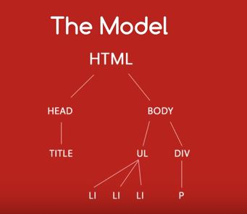Model: Model is parsing of those objects like a tree. There are hierarchy in HTML objects. A diagram will demonstrate that hierarchy.

Nodes: Nodes are those part of the HTML which can be changed. For example <head> can be changed and every elements and text inside that <head> can be changed. So texts and elements are also nodes. HTML attributes like href these are also nodes cause these can be changed by JavaScript.

SO WHAT CAN WE DO WITH THE DOM??!!

With DOM we can change the HTML nodes, we can change the background color, animation of the HTML pages.